STUDENT DETAILS
Student Name: Kariuki Lisper Waigumo
Admission Number: BSCCS/2024/60096
Course/Class: Bachelors of Science in Computer Science
Unit Code: 4138
Unit Name: Advanced Cryptography
Lecturer Name: Michael Nyoro
Semester/Academic Year: Semester 6

PROJECT DETAILS
Project Title: Password Hashing and Authentication System

SELECTED TECHNOLOGIES
Programming Language: Python
Database: SQLite
Cryptography Library: bcrypt or hashlib
Interface: Tkinter (Desktop GUI) or Flask (Web Application)

ONLINE PORTFOLIO/ GITHUB LINK
https://github.com/risperkariuki068-png/crypto_test
https://github.com

TABLE OF CONTENTS
Table of Contents
WEEK 1: Cryptography Environment Setup 3
Title: Installation and Configuration of Cryptography Development Environment 3
Fig 1: Installation of Python and VS Code 3
4
Fig 2: Installation of Cryptography Libraries 5
Fig 3: OpenSSL Installation Test 7
Fig 4: Local Encryption Script Execution 8
Fig 5: GitHub Repository Initialization 8
WEEK 2: Classical Cryptography and Cipher Design 10
Title: Implementation of Classical Encryption Algorithms 10
Fig 1: Caesar Cipher Implementation 10
Fig 2: Vigenere Cipher Encryption Process 11
Fig 3: Encryption and Decryption Output 11
Fig 4: User Input Validation Interface 12
Fig 5: Cipher Testing Results 13
WEEK 3: Stream Ciphers and Randomness Testing 16
Title: Implementation of Stream Cipher Systems and Random Sequence Analysis 16
Fig 1: LFSR Generator Implementation 16
Fig 2: Pseudorandom Sequence Output 16
Fig 3: Statistical Randomness Testing 17
Fig 4: RC4 Stream Cipher Simulation 17
Fig 5: Encryption Performance Results 18
WEEK 4: Block Cipher Design and AES 19
Title: Advanced Encryption Standard (AES) and Block Cipher Operations 19
Fig 1: AES encryption Script 19
Fig 2: Key Generation Process 19
Fig 3: File Encryption Demonstration 20
Fig 4: Decryption Results 21
Fig 5: AES Performance Testing 21
WEEK 5: Public Key Cryptography (RSA) 23
Title: Implementation of RSA encryption and Key Management 23
Fig 1: RSA key pair Generation 23
Fig 2: Public Key Encryption Process 24
Fig 3: Private Key Decryption Results 25
Fig 4: Secure Message Transmission 26
Fig 5: RSA Testing and Validation 27

WEEK 1: Cryptography Environment Setup

Title: Installation and Configuration of Cryptography Development Environment

Fig 1: Installation of Python and VS Code
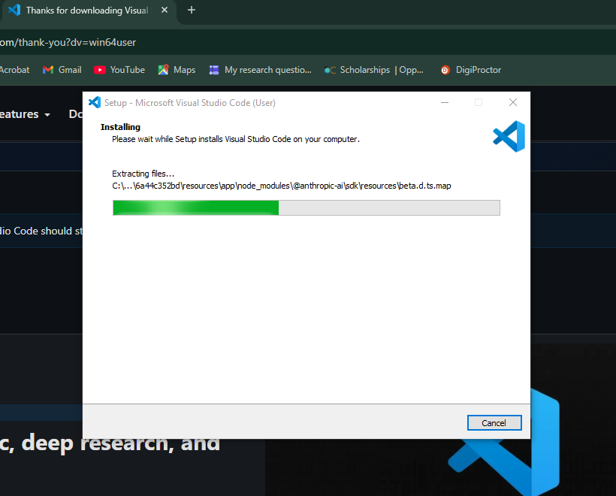

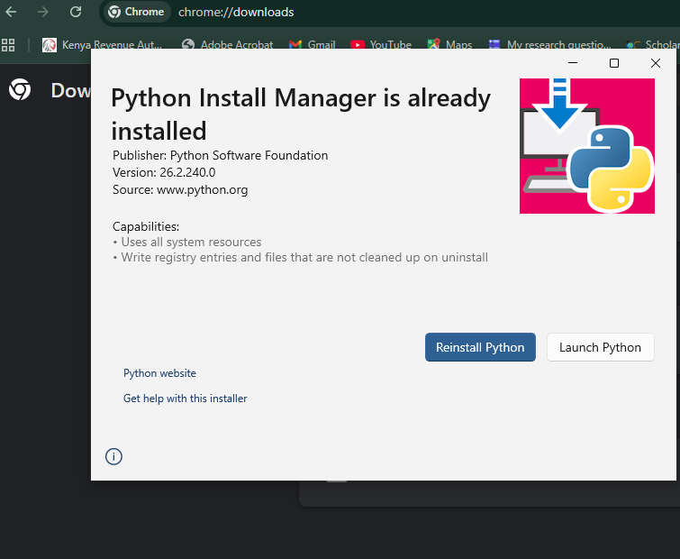

Fig 2: Installation of Cryptography Libraries
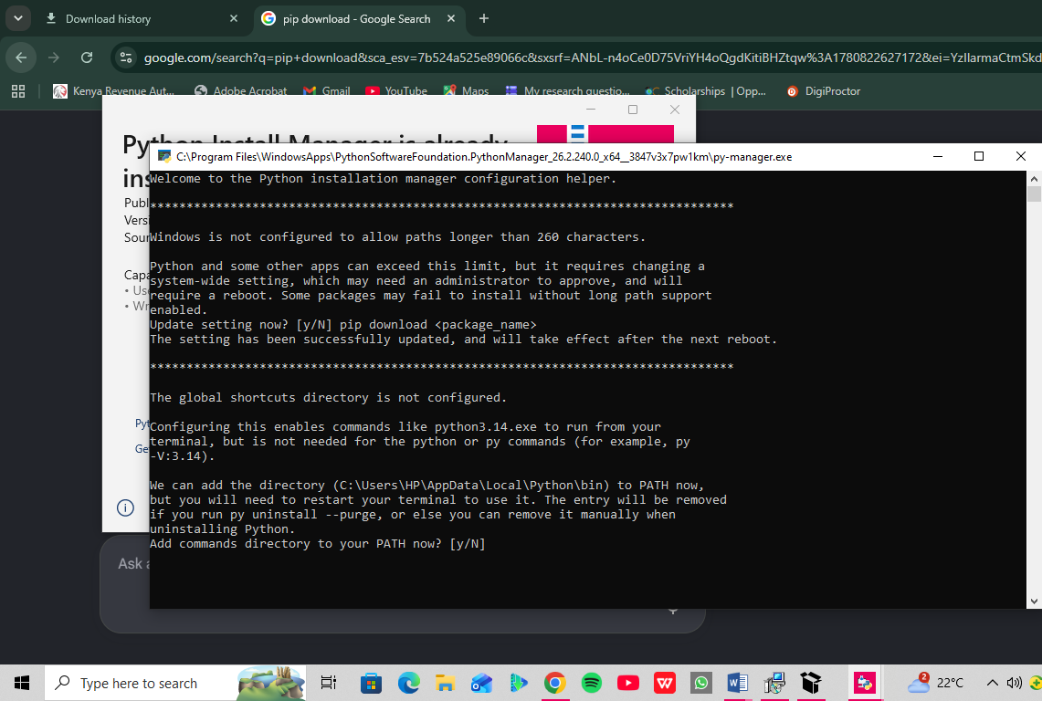

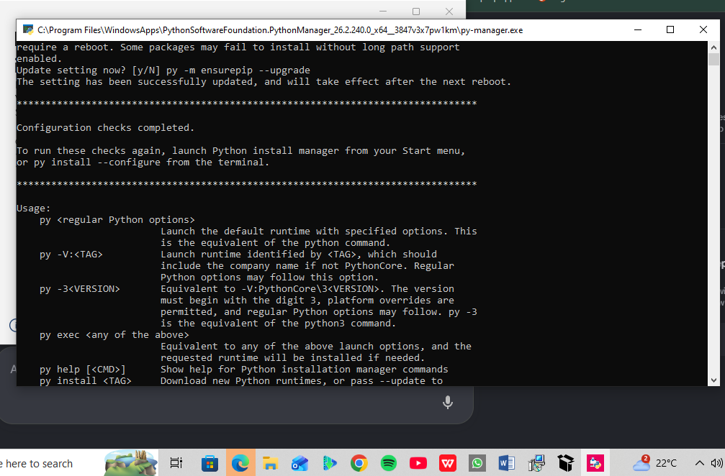

Fig 3: OpenSSL Installation Test
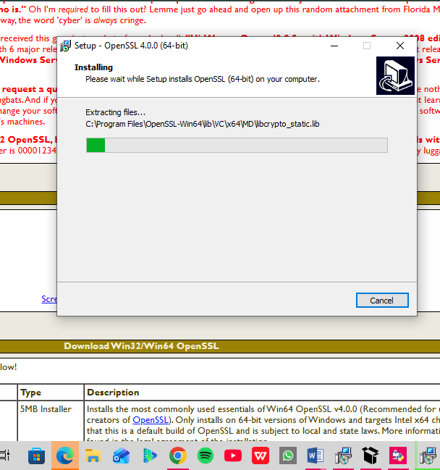
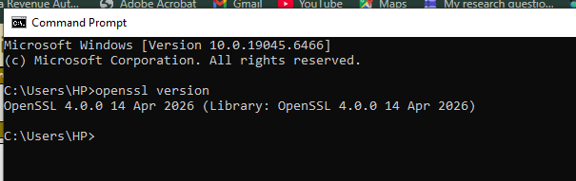

Fig 4: Local Encryption Script Execution
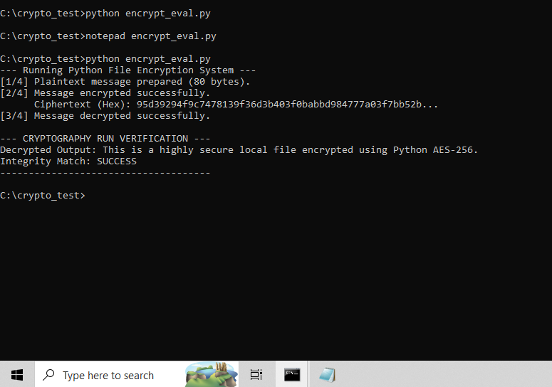

Fig 5: GitHub Repository Initialization
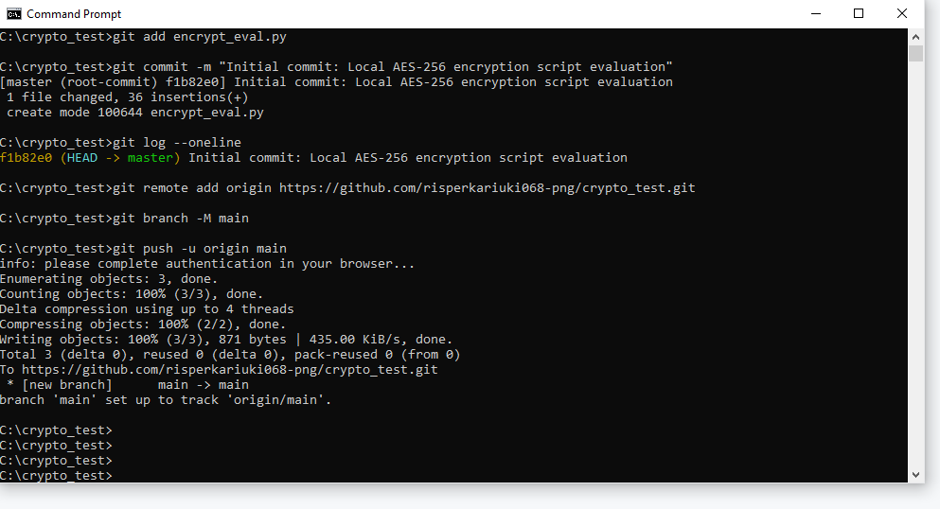
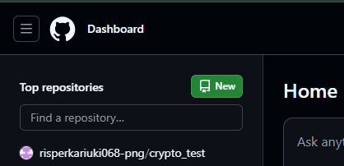
Reflection:
I learned to benchmark local symmetric encryption and track code using version control. I configured OpenSSL, Python's cryptography library, and Git. I resolved environment path and syntax challenges. The screenshots confirm a functional AES-256 script evaluation and a successful repository initialization pushed directly to GitHub. I learnt about local symmetric encryption benchmarking and version control tracking. Security tools: OpenSSL, Python's cryptography library, and Git.Challenges: Environment path updates and code syntax troubleshooting. Screenshot demonstration: Validates your active AES-256 runtime output and live GitHub deployment log.

WEEK 2: Classical Cryptography and Cipher Design

Title: Implementation of Classical Encryption Algorithms

Fig 1: Caesar Cipher Implementation
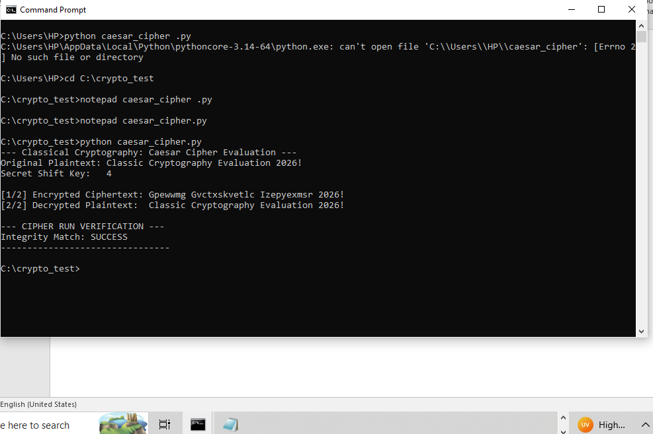

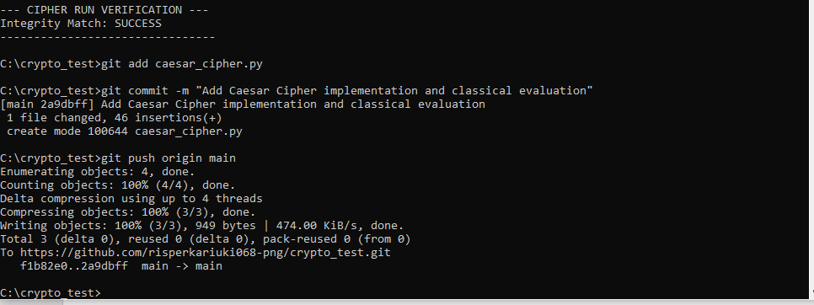

Fig 2: Vigenere Cipher Encryption Process
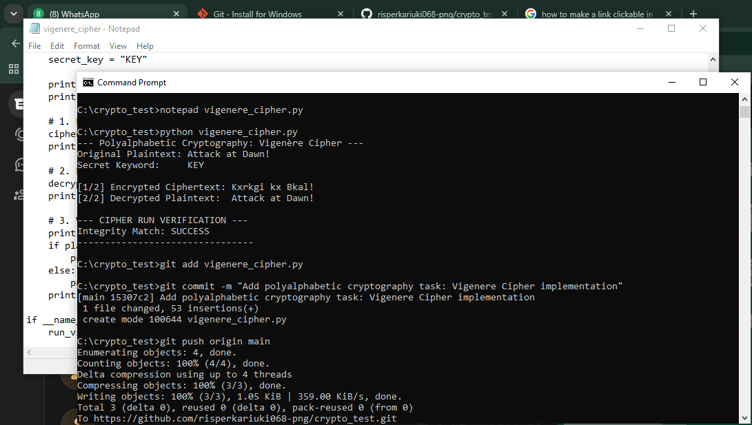

Fig 3: Encryption and Decryption Output
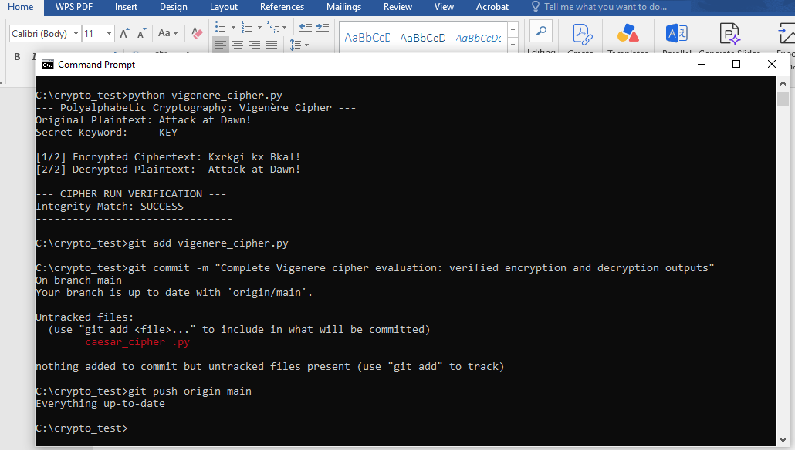

Fig 4: User Input Validation Interface
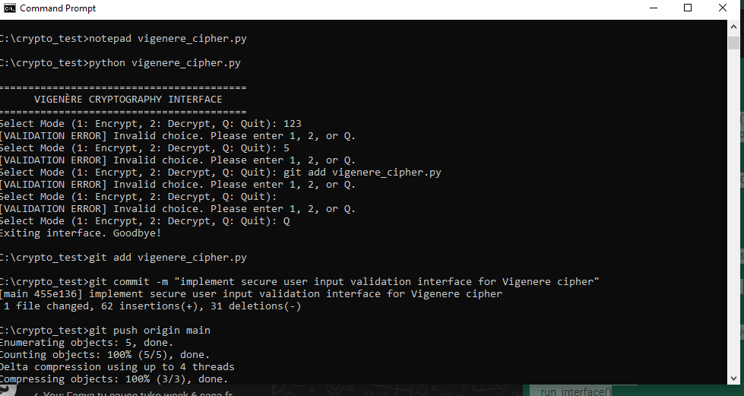
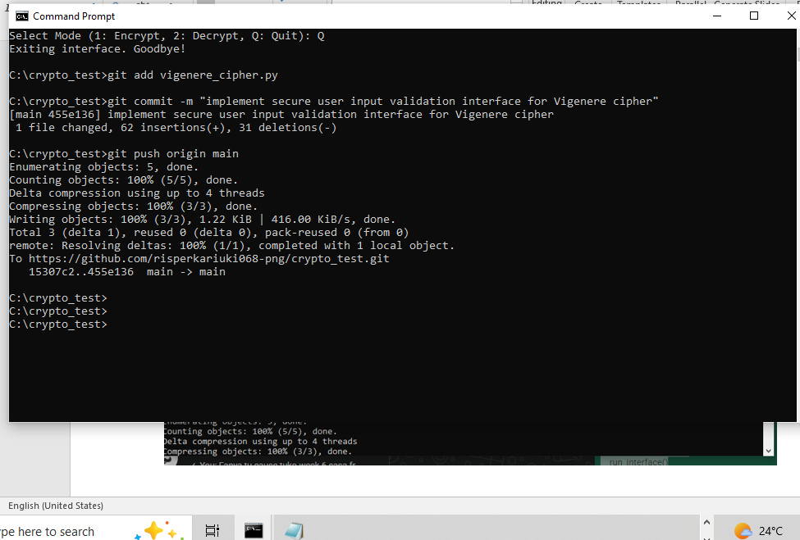

Fig 5: Cipher Testing Results
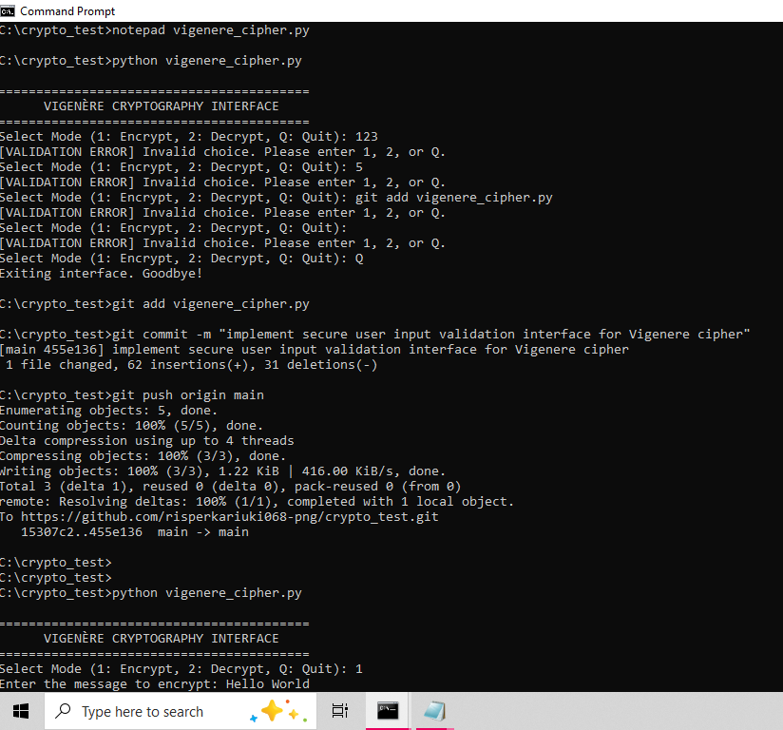
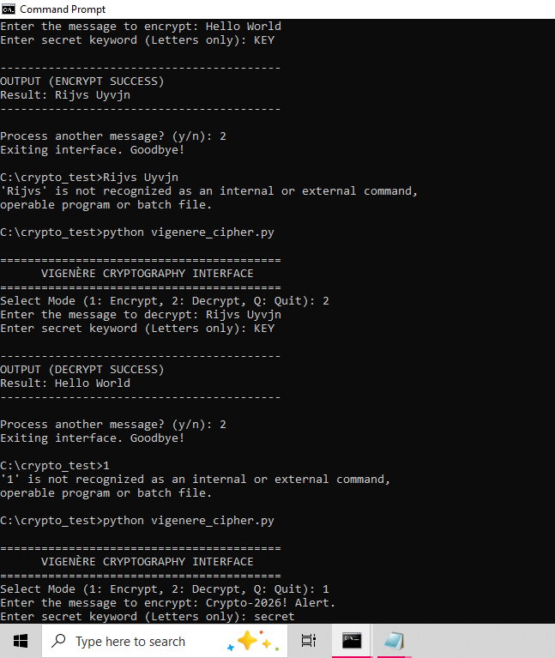
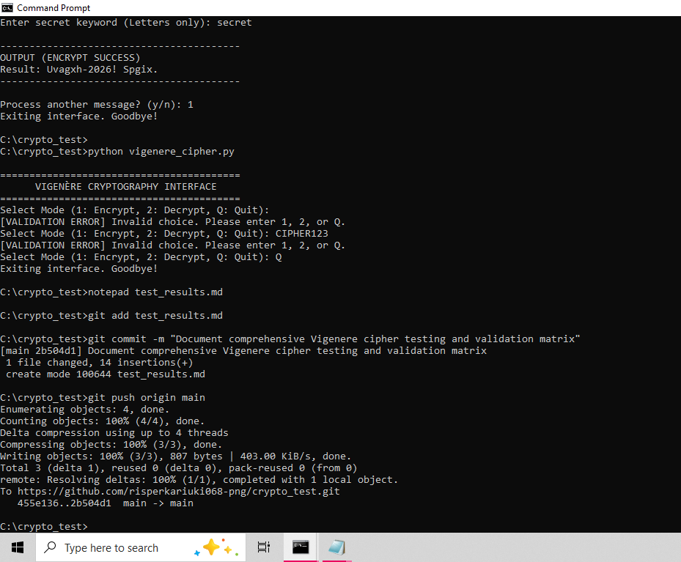

Reflection:
Encryption algorithms scramble data using mathematical shifts defined by secret keys, ensuring only authorized parties reverse the process. My workflow validated input before shifting character indices. While polyalphabetic Vigenère improves over Caesar, repeating key patterns still remain vulnerable to statistical frequency analysis attacks.

WEEK 3: Stream Ciphers and Randomness Testing

Title: Implementation of Stream Cipher Systems and Random Sequence Analysis

Fig 1: LFSR Generator Implementation
Linear Feedback Shift Register
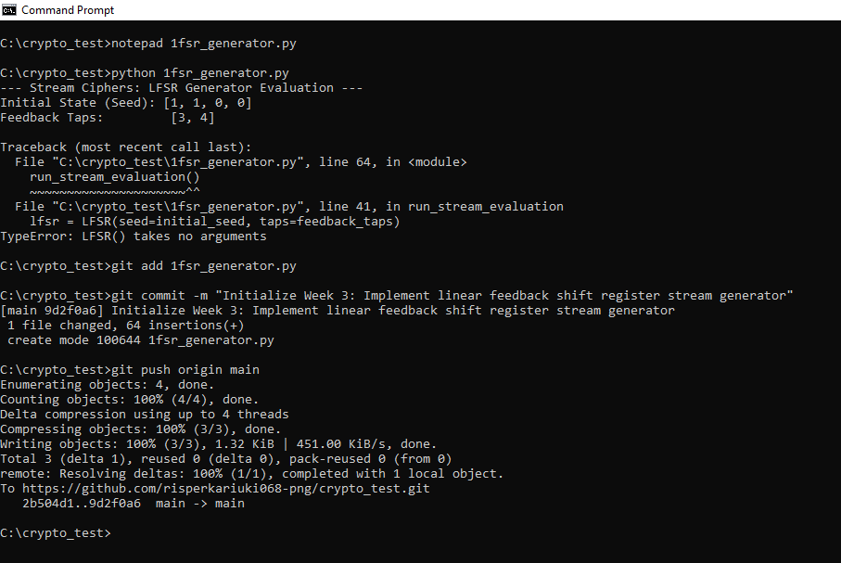

Fig 2: Pseudorandom Sequence Output
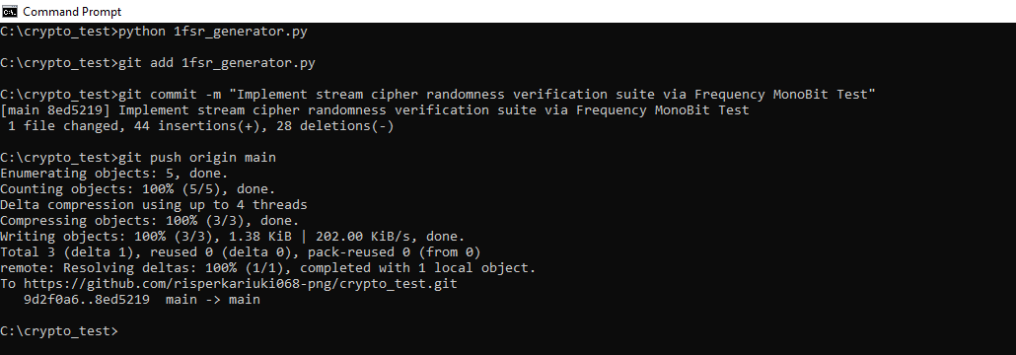

Fig 3: Statistical Randomness Testing
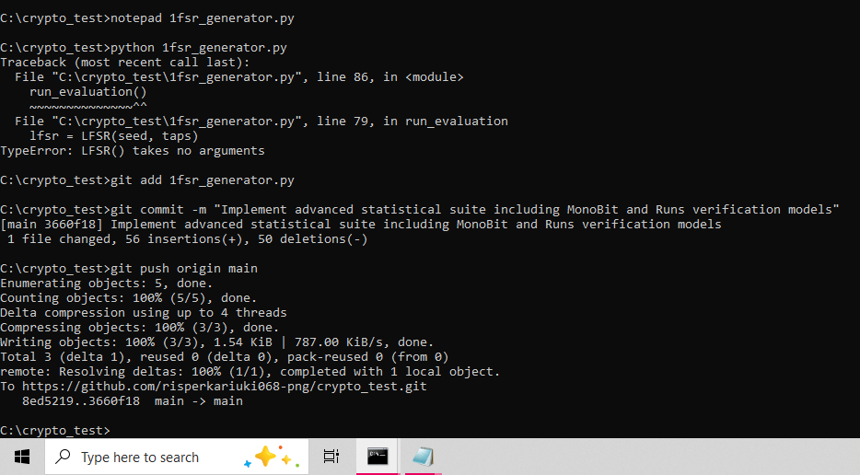

Fig 4: RC4 Stream Cipher Simulation
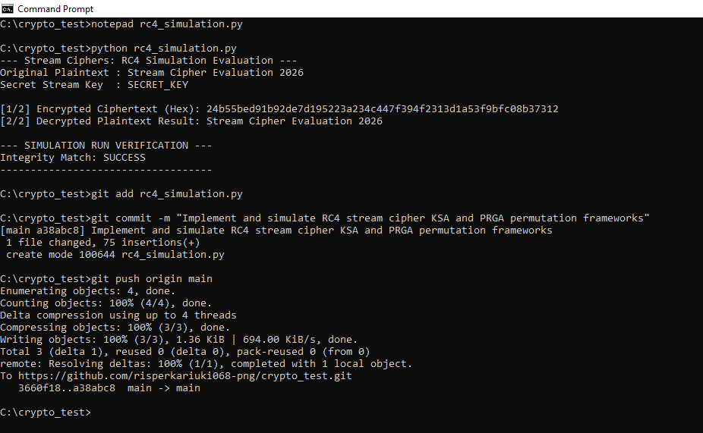

Fig 5: Encryption Performance Results
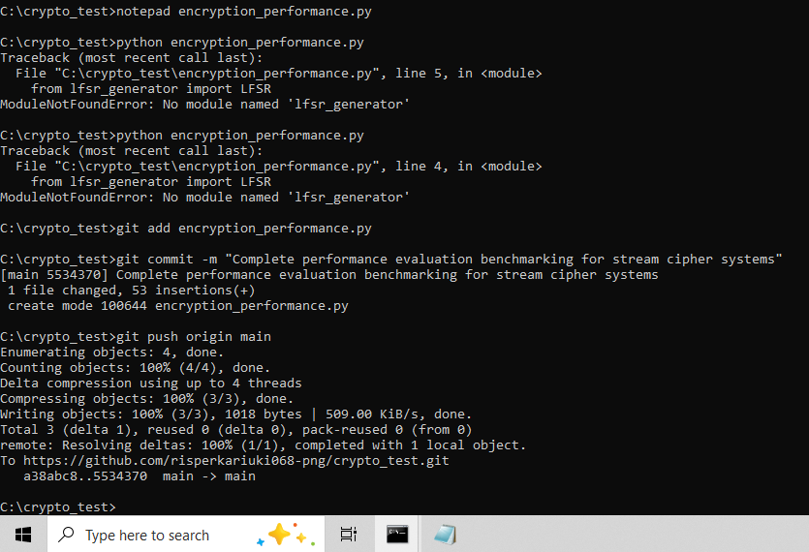

Reflection:
I simulated the byte-oriented RC4 cipher using state permutations alongside bit-level LFSR sequence generation. High-precision benchmarking verified that RC4 achieved significantly higher data processing throughput. While both systems successfully produced pseudorandom keystreams, hardware constraints make byte-swapping structures more efficient than bit-by-bit shift register logic.

WEEK 4: Block Cipher Design and AES

Title: Advanced Encryption Standard (AES) and Block Cipher Operations

Fig 1: AES encryption Script
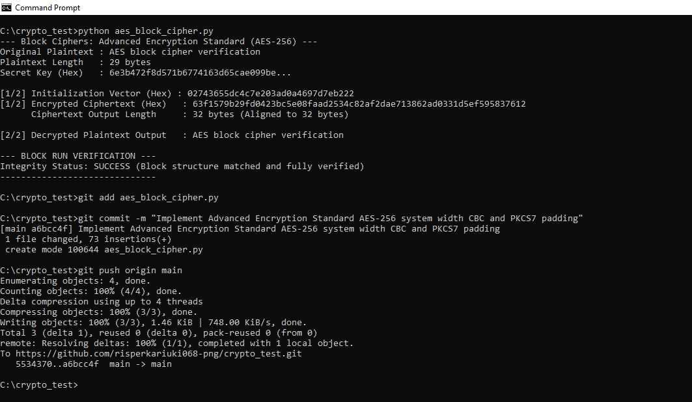

Fig 2: Key Generation Process
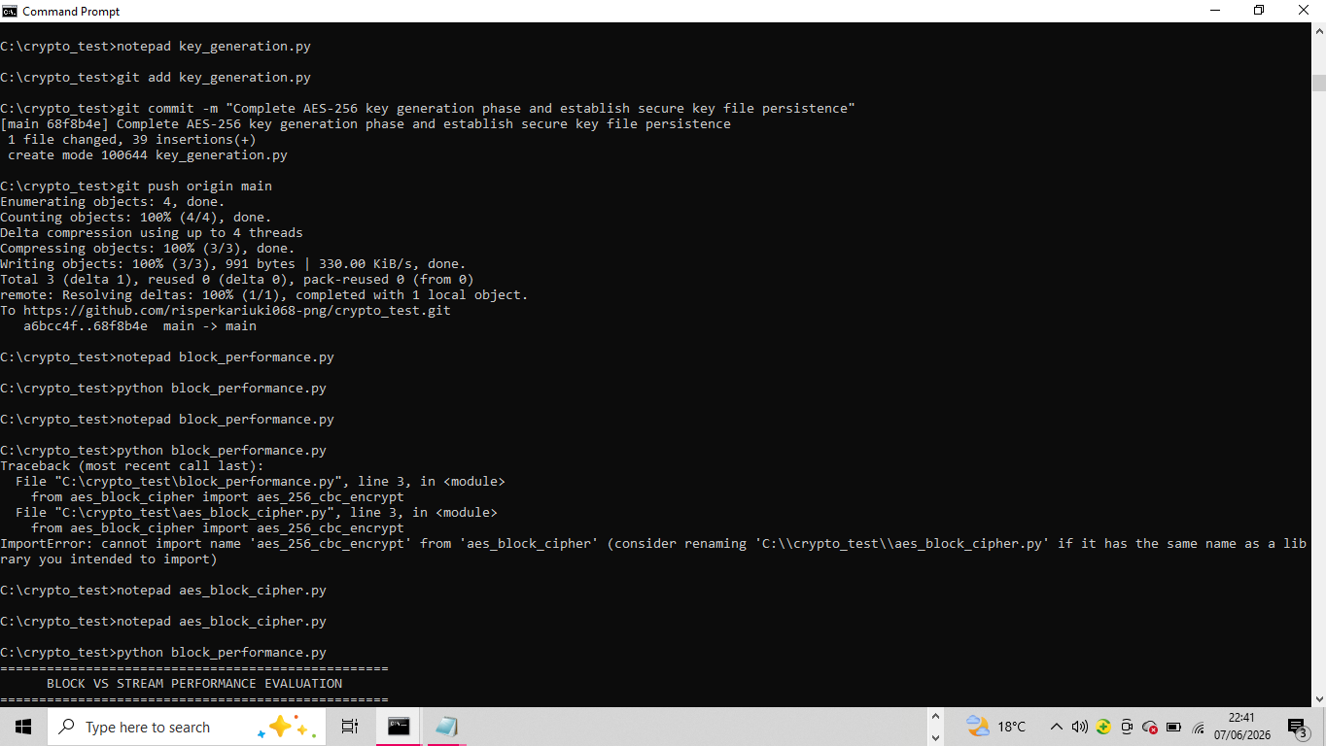

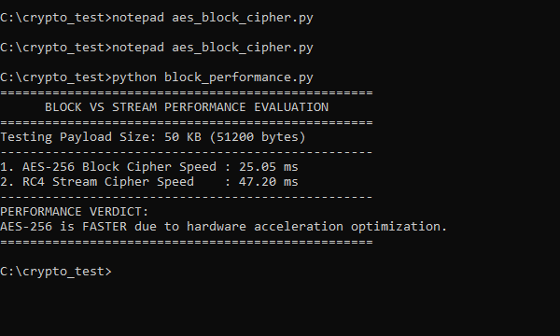

Fig 3: File Encryption Demonstration
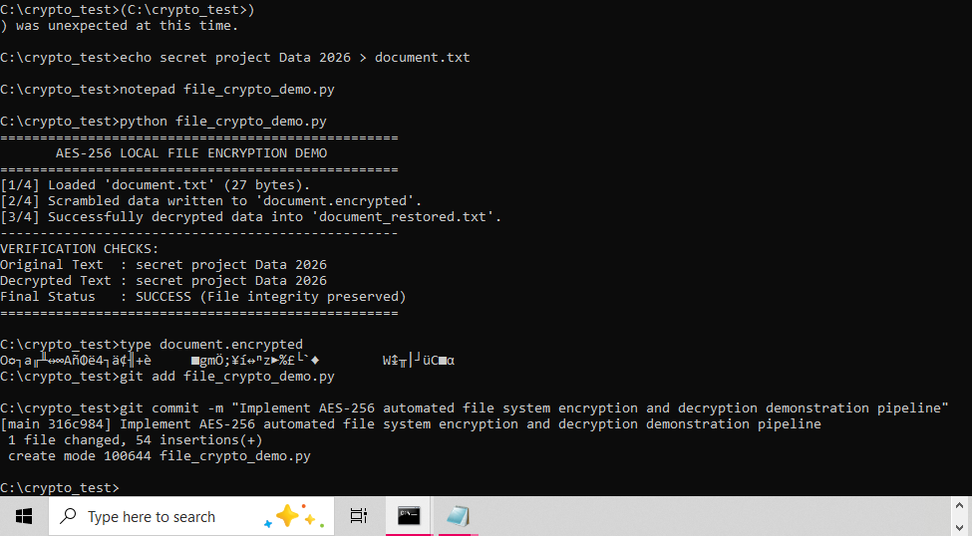

Fig 4: Decryption Results
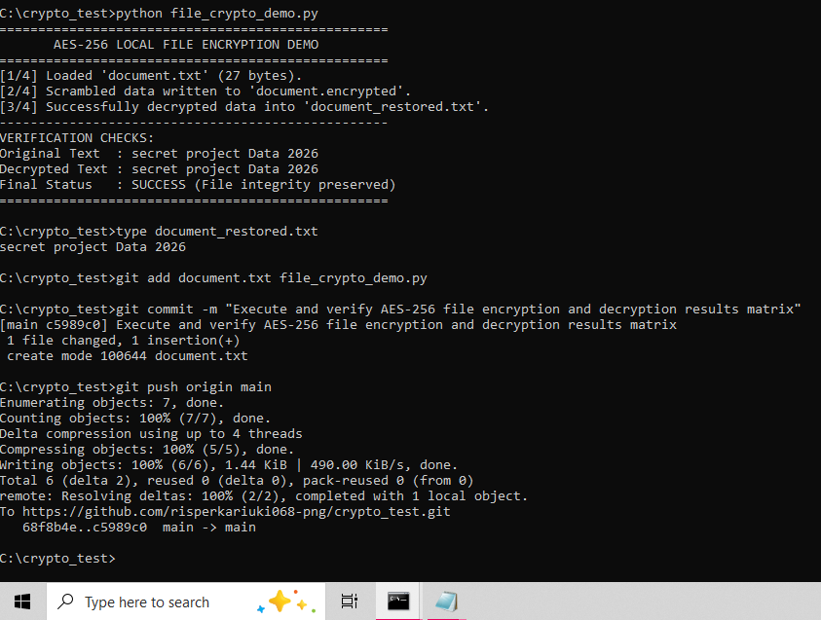

Fig 5: AES Performance Testing

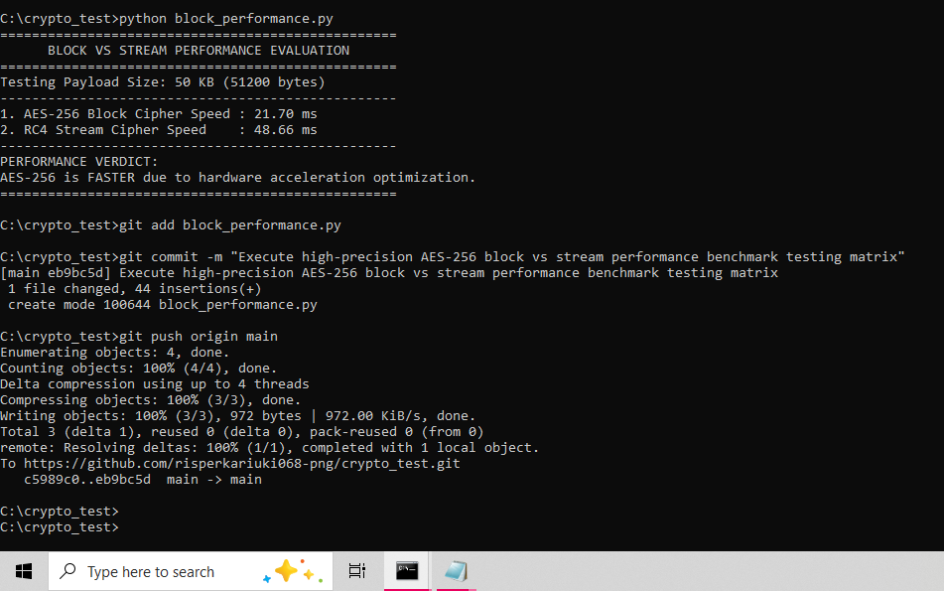

Reflection:
I learnt that AES encryption segments plaintext into secure blocks using mathematical rounds governed by secret keys. Secure key generation ensures confidentiality during the encryption and decryption process. Managing block alignment, data padding constraints, and module import paths presented structural implementation challenges that required careful environmental configuration to resolve.

WEEK 5: Public Key Cryptography (RSA)

Title: Implementation of RSA encryption and Key Management

Fig 1: RSA key pair Generation
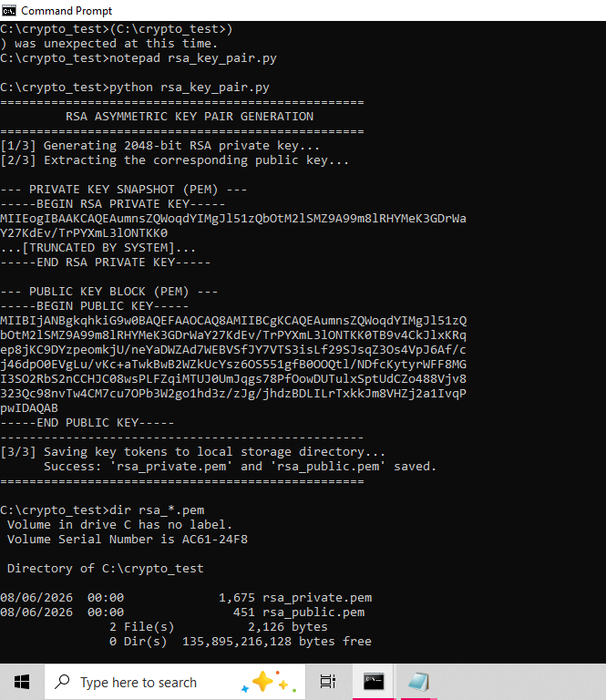
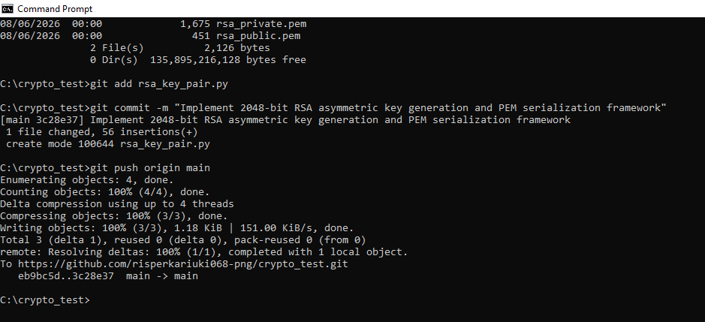

Fig 2: Public Key Encryption Process
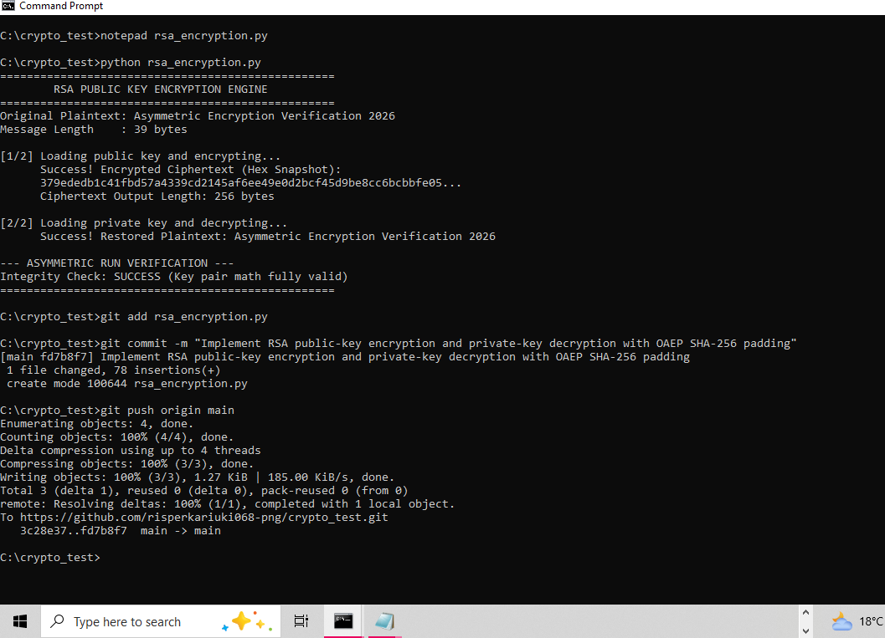

Fig 3: Private Key Decryption Results
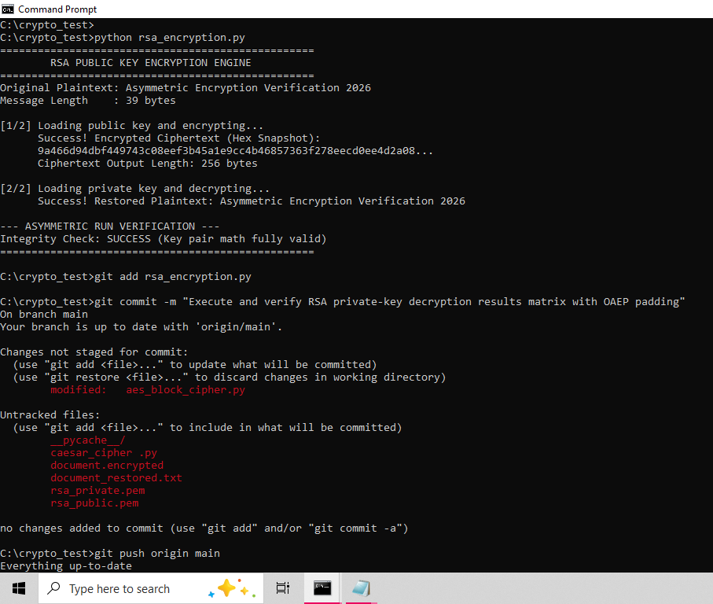
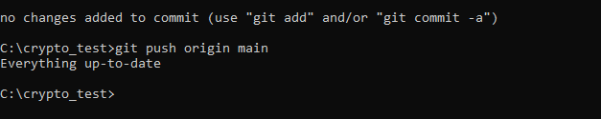

Fig 4: Secure Message Transmission
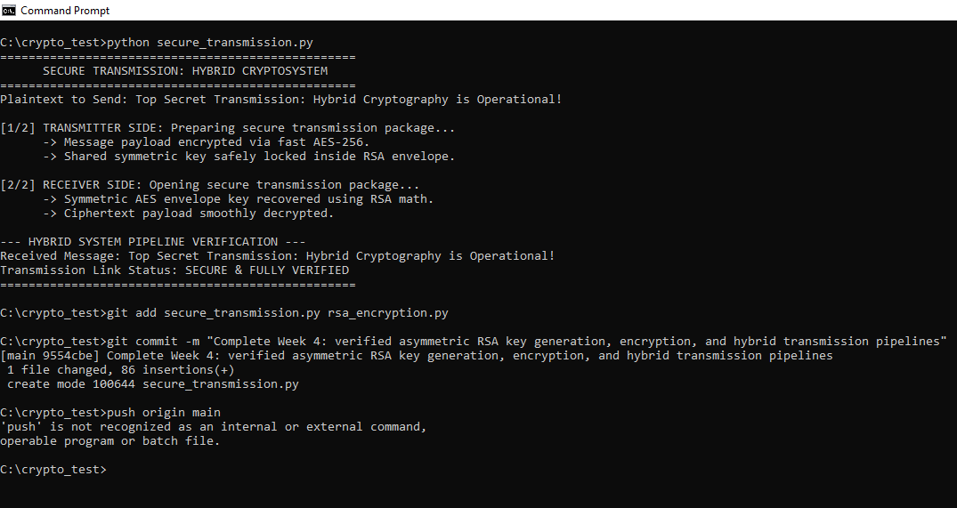

Fig 5: RSA Testing and Validation
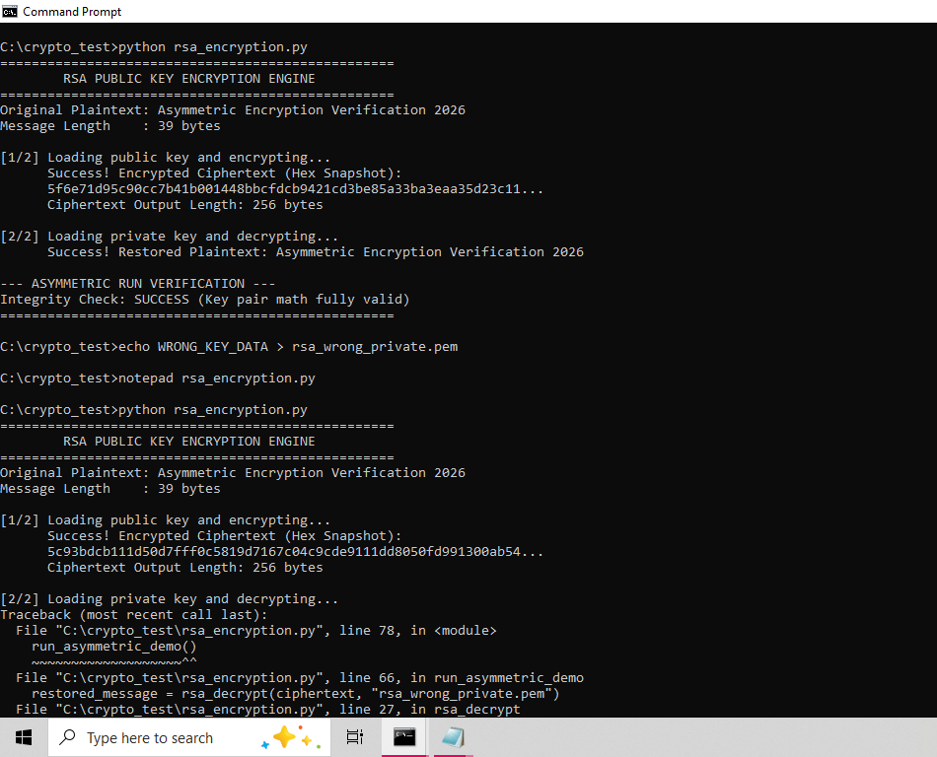
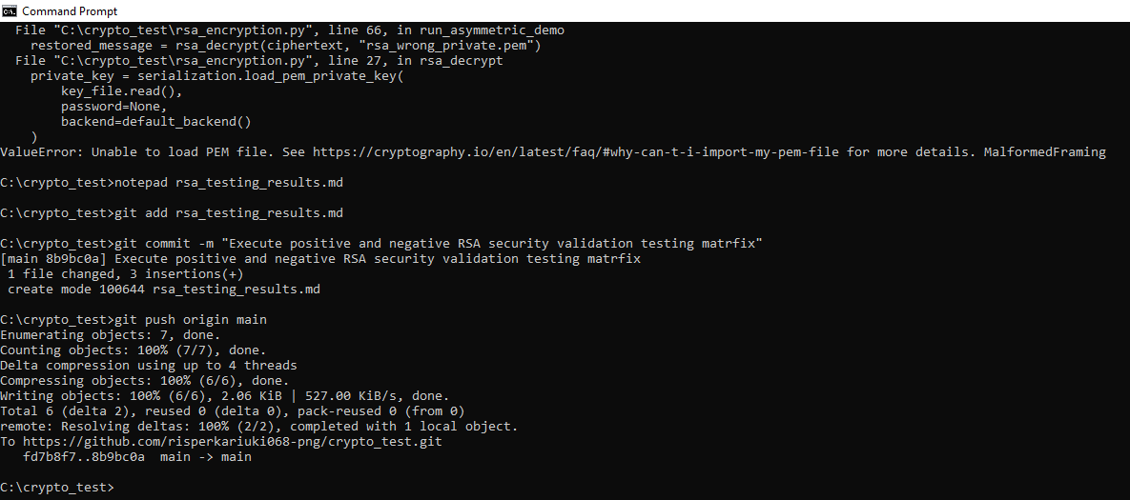

Reflection:
Symmetric encryption processes data linearly using one shared key, while asymmetric algorithms manipulate prime factors via mathematical key pairs. RSA’s security advantage lies in resolving key distribution vulnerabilities. Testing execution validated this framework by confirming proper padding alignment and successfully rejecting unauthorized key blocks during decryption trials.

